User’s Guide for ImageJ Plugin Measure_Line

1. Before you begin, you must photograph the pieces (at the same magnification for each) and import them into one composite image. You can use any graphics program for this, or ImageJ itself; save the composite in either tiff or jpeg format. Flatten layers if that is presented as an option. If you want to obtain piece lengths (not necessary for frequency mapping), you need to photograph a scale bar and include it in the composite image as well. Make a note of any piece that is upside-down relative to the others – this is important later.
2. Download ImageJ from NIH, at http://rsbweb.nih.gov/ij/ or Fiji at https://fiji.sc/
3. Download “Measure_Line.class” from the Eaton-Peabody website, and copy it into the directory ImageJ\Plugins\Tools.
4. Open ImageJ, and then open the composite image of the cochlear whole mount pieces. (If the image won’t open, or the program does not work correctly once you get started, you may not have enough memory allocated to ImageJ. You can check this within ImageJ using Edit/ Options/ Memory & Threads… . If you change the memory allocation, you’ll need to restart ImageJ.)
5. Start the Measure_Line plugin (Plugins/Tools/Measure Line).
6. Select the “Segmented Lines” tool from the “Straight Line” list on the toolbar (for Mac, use command-click to display options).
Starting with the basal-most piece, position the cursor over the basal end of the organ of Corti and left-click to begin. Trace over the organ of Corti with the cursor, left-clicking as you go, to lay down a segmented line along the organ of Corti’s path. Right-click or double-click to end the tracing at the apical edge of the piece. Hit “d” (for “drawing”) on the keyboard. The Measure_Line plugin will automatically do a spline fit to smooth the tracing, and apply a numeric label to the piece.
Repeat this procedure for all the pieces. VERY IMPORTANT: the tracings must be done from base to apex, both in order of pieces traced, and in direction of tracing within each piece.
The direction of tracing is established with the basal-most piece, where you can see the starting point of the organ of Corti. If you rotate the individual photos as you import each one into the composite so that they all have the same orientation, then you simply trace in the same direction on each piece. If any piece is upside-down relative to the others on the microscope slide, the directionality of that piece is reversed.

7. The plugin is programmed to use yellow for the traces and piece labels applied in the previous step, but you can select the color for the frequency labels that will be added in the next step. The default is white, which shows up well against the dark background of fluorescent images. However, a different color may be chosen using the “Foreground” field of the Edit/ Options/ Colors… window.

8. Now press “a” on the keyboard (for “annotation”). A window will pop up asking which species it is. Enter the species number and click “OK”.

Nine points with octave and half-octave frequencies will be labeled on the cochlear tracings in the foreground color you just chose (or white). Save the file.
The frequencies are calculated based on percent distance from base, so you need to trace over the same feature in each piece (inner hair cells, outer hair cells, tunnel, etc.). If there is a piece missing, the frequencies cannot be mapped. Therefore, save and photograph even badly damaged pieces – there is often enough tissue remaining that a tracing can be drawn over the estimated location of the (missing) organ of Corti.
If the option “Equal Division” is selected, then the whole cochlear length will be binned into equal-length segments instead of mapped, and dividing lines displayed on the pieces. The number of bins is specified by the user. The example below shows a piece from a mouse cochlea where 20 divisions were specified. Binning is useful for counting haircells and plotting cytocochleograms.

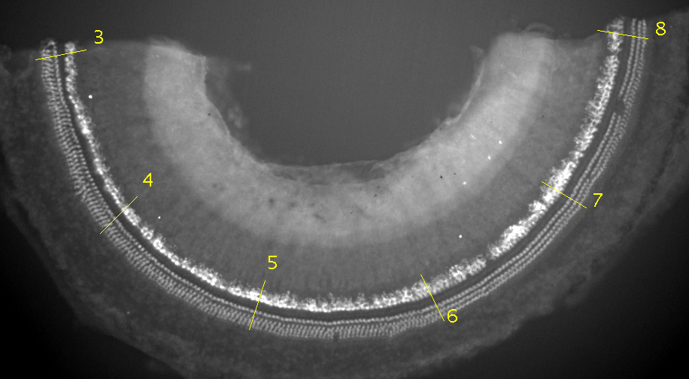

9. Additional features (for use before you close the mapped composite image):
- To get piece lengths: press “m” (for “measurement”) on the keyboard to display a “Measurements” window listing the length of each cochlear piece and the total. If you have done a calibration, the lengths will be in the unit of calibration; otherwise they will be in pixels. Calibration instructions are below (item 10). You can save the piece lengths by saving the Measurements window (File/ Save as…); the information is not saved with the image file.
- To find the frequency at a particular location: press “p” (for “pointing”) on the keyboard to activate “pointing mode”. Select the scrolling tool on the toolbar.
Position the cursor anywhere along the cochlear tracings, and the frequency at that location will be displayed at the bottom of the tool bar. Left-click to add a frequency label to the image. (Change the foreground color first, as described previously, if you want these labels in a different color.)

10. Calibration – this, too, can only be done while the composite image is open at the time of mapping, either before or after the mapping itself:
- There must be a scale bar included in your composite image (photographed at the same magnification as the pieces).
- Using the “Straight Line” tool, trace the length of the scale bar by clicking and dragging the cursor from one end to the other.
- Use the Analyze/ Set Scale… menu item to display the calibration window. Enter the “Known Distance” and the “Unit of Length”. Click “OK”, and the calibration will be applied to the image. If you check the “Global” box, the calibration will be used for all the images opened during the same session of ImageJ.

NOTE: to reiterate, the features described in (9) and (10) can only be used while the composite image remains open at the time of mapping. When the file is closed, the piece length measurements are not stored with the image, and so cannot be displayed, pointed at, or calibrated upon re-opening.

